Afeef Akhtar
Project 1 Report
ECE 465
Umer Cheema
For this project, I am to design an 8-bit ALU using Quartus and testing it on ModelSim. Building off the tutorial in class, I created 3 input variables, 2 8-bit inputs for the operands and 1 2-bit input for the opcode, and 2 output variables for both the 8-bit out variable and a carry out. I have also assigned 4 parameters that assign the ADD, SUB, TWO, and XOR command to their respective 2 bit inputs which will be read by the opcode variable. In the main block, I did a case statement with opcode where it will perform their respective arithmetic operations depending on the input read. Using the RTL viewer, it generated this schematic:
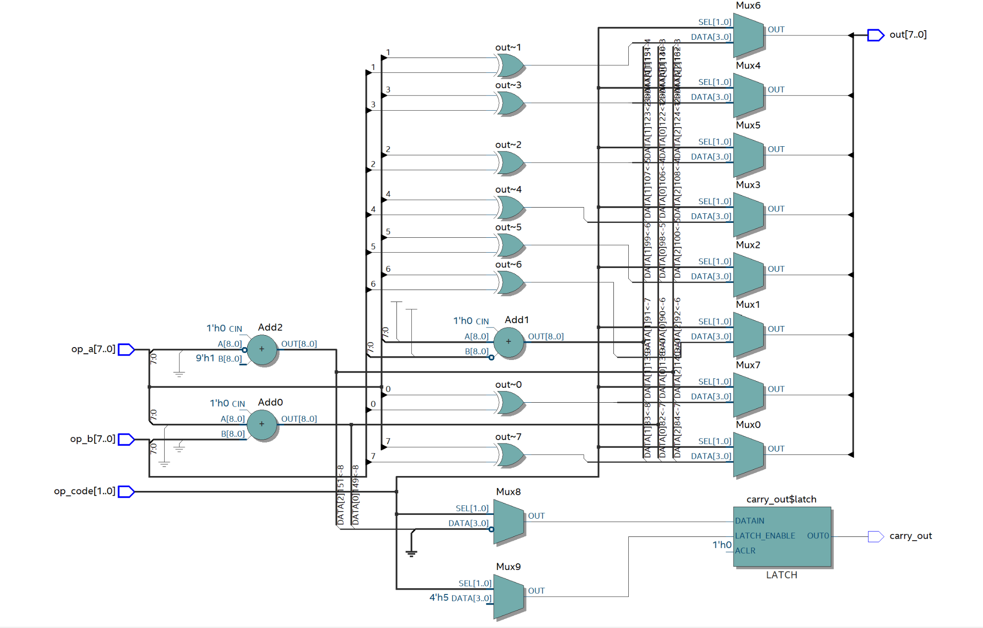

This is the code I have written:
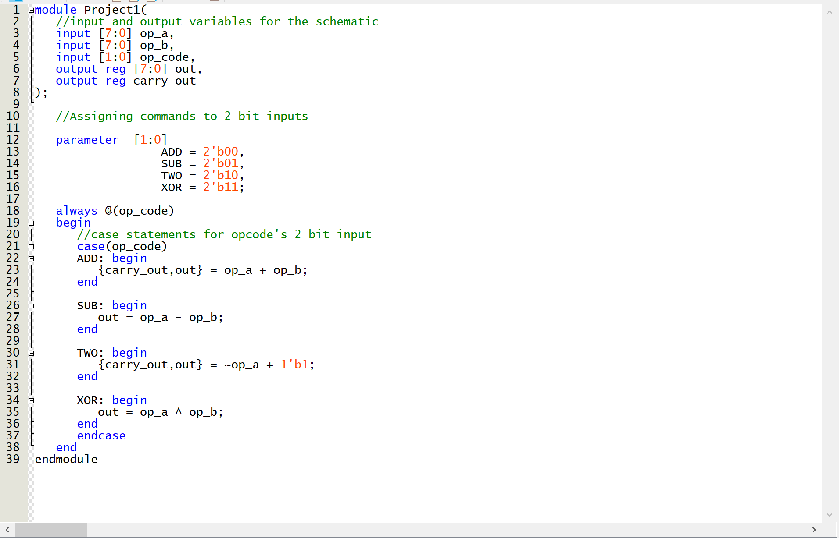
This project certainly was a good starting point for using both Quartus and ModelSim. It has challenged my way of thinking to design a schematic by writing code alone. I look forward to the future projects in this class.

